**Practical: - 05 Use git pull to get your partner change into your repository. Verify that you have the new file.**

**Name: - Vaishnavi Kamalkishor Agrawal**

**Roll No: - 02**

-----------------------------------------------------------------------------------------------

agraw@DESKTOP-EE480I5 MINGW64 ~

$ cd MyRepo

agraw@DESKTOP-EE480I5 MINGW64 ~/MyRepo (main)

$ git init MyRepo

Initialized empty Git repository in C:/Users/agraw/MyRepo/MyRepo/.git/

agraw@DESKTOP-EE480I5 MINGW64 ~/MyRepo (main)

$ git pull https://github.com/vaishu10702/MyRepo.git

remote: Enumerating objects: 4, done.

remote: Counting objects: 100% (4/4), done.

remote: Compressing objects: 100% (3/3), done.

remote: Total 3 (delta 0), reused 0 (delta 0), pack-reused 0

Unpacking objects: 100% (3/3), 11.43 KiB | 468.00 KiB/s, done.

From https://github.com/vaishu10702/MyRepo

* branch HEAD -> FETCH_HEAD

Updating 4717c51..c8350b5

Fast-forward

Practical 7.3.docx | Bin 0 -> 13716 bytes

1 file changed, 0 insertions(+), 0 deletions(-)

create mode 100644 Practical 7.3.docx

agraw@DESKTOP-EE480I5 MINGW64 ~/MyRepo (main)

$

**Before pull**

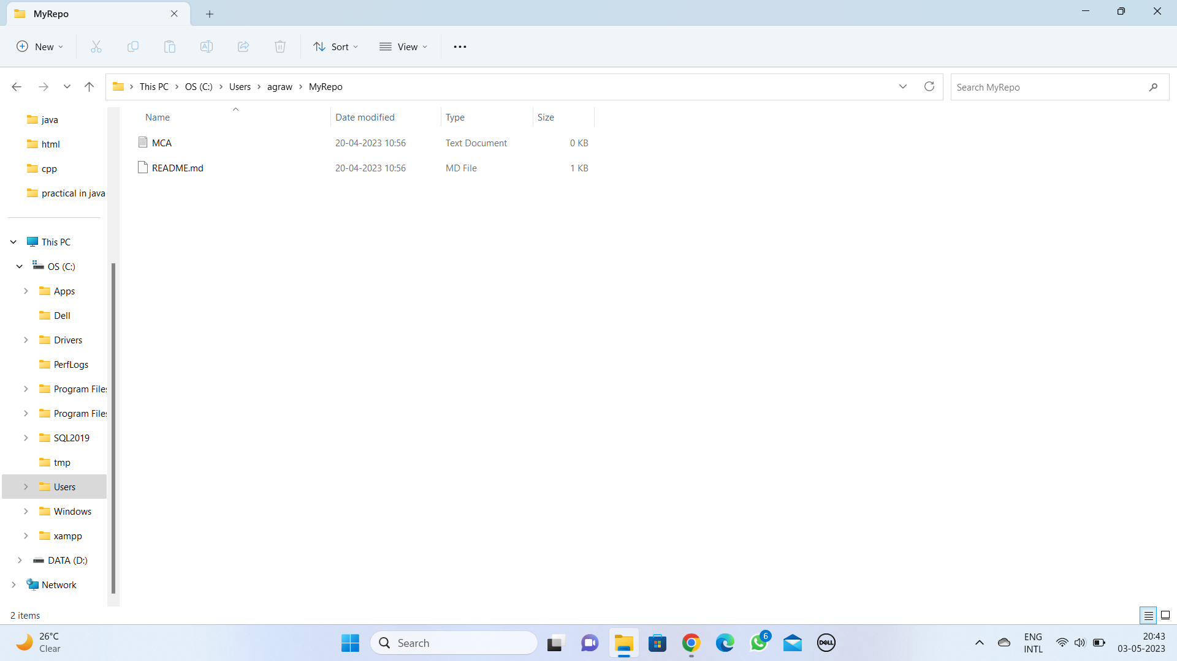

**After pull**

